# EDUCATION

|  |  |  |  |  |
| --- | --- | --- | --- | --- |
| **Course** | **Subject** | **Institute** | **Year of Pass** | **Percentage/CGPA** |
| B-Tech  (Pursuing) | Information  Technology | MGIT, Hyderabad | 2023 | 7.88 CGPA |
| Intermediate | MPC | Narayana Junior College, Hyderabad | 2019 | 95..7% |
| Secondary School Certificate | SSC | Vijaya Ratna High School, Hyderabad | 2017 | 9.5 CGPA |

NADIMPALLI SAHITHI

Determined, Team Player, Innovator. 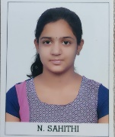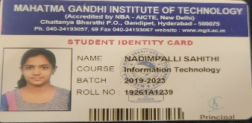

nsahithi_it191239@mgit.ac.in

Mobile: +91 9676985735

# SKILLS

C

C++

Java programming

PYTHON(basics)

HTML

CSS

# TRAINING AND CERTIFIED COURSES

* Certified on successful completion of project on “Data Science” from Exposys Data Labs.
* Certified on successful completion of java fundamentals and programming from “TASK”.
* Certified on successful completion of ‘Digital 101 journey’ by NASSCOM.
* English Grammar - Hebeon 2021.

# AWARDS AND HONORS

* Received second prize in essay writing competition at mandal level-2017
* Certified on rendering services for “STREET CAUSE”.

# WEBINARS AND WORKSHOPS

# Communication skills “Beyond Syllabi”-2019

# Microservices Architecture using Java technologies-2020

# Attended 2 day “ Workshop on data analytics “ on 22nd May 2021 in association with Pantech-e-learning

# Personal Details

# Father’s Name : N.V.R.K Raju

# Nationality: Indian

# Languages Known : Telugu, Hindi, English

# Marital status: unmarried

# Date of Birth: 08/06/2002